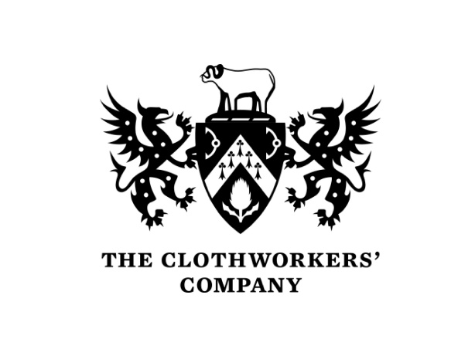




Fashion & Textiles Sustainability Strategy Programme Pilot
Project Evaluation Report

Contents

Executive Summary Page 2

The Report Page 3

Appendix 1: Participating Companies Page 14

Appendix 2: The IMD Programme Page 16

Appendix 3: Participant Feedback Analysis Page 19

Appendix 4: Company Actions and Testimonials Page 32

Executive Summary

In 2020 and 2021, as part of the ‘Let’s Talk Real Skills’ project, the Textile Centre of Excellence developed and delivered a number of ‘skills audits’ with companies across the sector which identified areas of need where content was lacking. One key area was a need to understand the challenges and opportunities presented by the increasing focus on sustainability and the circular economy.

While some advice and capital support existed locally, companies were faced with a range of short-term initiatives, a lack of impartial, expert advice and a bewildering range of confusing terminology which often led to inactivity.
The Centre recognised the need for a practical programme to provide manufacturers with the analytical tools to identify where to start the process of identifying and prioritising risks and opportunities, alongside support to develop a company strategy to implement change involving all employees. The Centre engaged the International Institute of Management Development in Lausanne Switzerland and their ‘Winning Sustainability Strategies’ programme for the pilot along with Dr Mark Wade to provide expert support to companies. The Centre proposed the development and delivery of an 8-month pilot programme for 20 delegates drawn from 10 companies.
Financial support for the delivery and evaluation of the pilot programme was kindly provided by the Arts and Humanities Research Council (via the Future Fashion Factory programme), the Clothworkers’ Company and the Cotton and Textiles Research Trust.
The pilot programme involved initial assessment visits to companies, participation in the IMD on-line programme, learning reviews and company planning sessions. Evaluation, which commenced in January 2023 clearly identified the value and impact of the programme and identified a number of recommendations for follow-on activity including:

- The development of a standard set of ‘Sustainability KPIs’.
- The creation of a Sustainability Champions’ Network
- The creation of a customised IMD ‘Winning Sustainability Strategies’ Programme for the Sector
- The creation of a company audit Support/Tool
- The extension of the Programme to a second cohort of companies

This report aims to provide information that will inform a discussion with the industry and supporting agencies to steer the future approach.

Introduction
In 2020 and 2021, as part of the ‘Let’s Talk Real Skills’ project, the Textile Centre of Excellence developed and delivered a number of ‘skills audits’ with companies across the sector to identify their current and predicted skills needs. Those audits were revisited in 2022 to identify the impact of the pandemic and ‘Brexit’ on companies’ markets and operations. Three specific areas were identified where relevant training content was lacking:

- Knowledge of the use of digital technologies to improve efficiency;
- Developing the engineering skills of textile manufacturing technicians, preferably through an existing apprenticeship programme;
- Understanding the challenges and opportunities presented by the increasing focus on sustainability.

The Centre addressed those needs as follows:
- The Centre partnered with Calderdale College and West Yorkshire Manufacturing Services to create a model for an ‘Industry 4.0 Digital Hub’ in Brighouse. Funding has been secured from the Towns Fund to develop the WYMS premises and a new range of introductory I4.0 courses is being developed to increase knowledge and accelerate SMEs’ take-up of ‘enabling technologies’;
- A new ‘hybrid apprenticeship’ incorporating engineering and textiles technical skills has been created in collaboration with Calderdale College and will be launched in the autumn of 2023;
- The Centre created and delivered a pilot company sustainability strategy programme to test a new model for knowledge delivery and practical expert support.
Sustainability Policies
Sustainability has become a policy priority across the UK for both national and regional governments. Many have declared ‘climate emergencies’, often without having strategies in place to achieve their ambitious ‘net zero’ targets.
The Leeds City Region has declared a climate emergency with a target of net zero carbon by 2038 - equivalent to a 14.5% reduction per year. The Local Enterprise Partnership is providing advice and grants to help SMEs reduce their energy and water use and waste costs and is bringing low carbon, lower cost heating and hot water to the city of Leeds while also cutting 22,000 tonnes of carbon emissions every year. In addition, the LEP’s Energy Accelerator Programme is supporting SMEs’ low carbon and energy efficient’ projects by providing capacity, expertise and funding.

In business, large companies are increasingly requiring compliance from their supply chains and some investors are seeking ‘climate related financial disclosures.’ For some companies, their cost and risk concerns can be outweighed where they can identify new opportunities arising from the circular economy and lever value from sustainability, moving beyond compliance to generate competitive advantage.

Meanwhile, companies are faced with a range of short-term initiatives, a lack of impartial, expert advice and a bewildering range of confusing terminology referring to Sustainability, Circularity and Circular Economies, Environmental, Social and Governance policies (ESG), Business Continuity, Net Zero, Carbon Neutral and Offsetting, creating confusion which can often lead to inactivity.
The Workshop
The Centre recognised the need for a practical programme to provide manufacturers with the analytical tools to identify where to start the process of identifying and prioritising risks and opportunities, alongside support to develop a company strategy and implement change involving all employees.
Current knowledge provision was analysed including the Oxford Online: ‘Leading Sustainable Corporations Programme’: an 6 week online programme requiring 7 to 10 hours a week study through to the level 6 Environmental Practitioner Degree Apprenticeship, delivered by the University of Coventry leading to Registered Environmental Practitioner (REnvP) registration, at level 5.
After discussion with the International Institute of Management Development in Lausanne Switzerland the Centre chose the IMD ‘Winning Sustainability Strategies’ programme for the pilot. The level of the content was considered more appropriate to an SME audience and the online programme appeared, initially, to demand less study time from delegates.
The Centre was introduced to Dr Mark Wade as a potential expert to support companies. Mark joined Shell in 1977 and was a founder member of their Sustainable Development Group set up in 1997. He served as Shell’s Liaison Delegate to the World Business Council for Sustainable Development. Mark is respected internationally for helping companies and institutions integrate sustainability into strategy, operations, markets, leadership and culture.
In order to consult companies on the proposed approach, on 13th October 2021 the Centre organised a ‘Creating Value from Sustainability’ Workshop. The Workshop, which included 21 delegates from 14 companies was led by Dr. Wade. The Workshop also featured case studies from leading companies including Wools of New Zealand and bed manufacturer Harrison Spinks along with input from the West Yorkshire Combined Authority who outlined the support available for businesses to improve their sustainability practices.

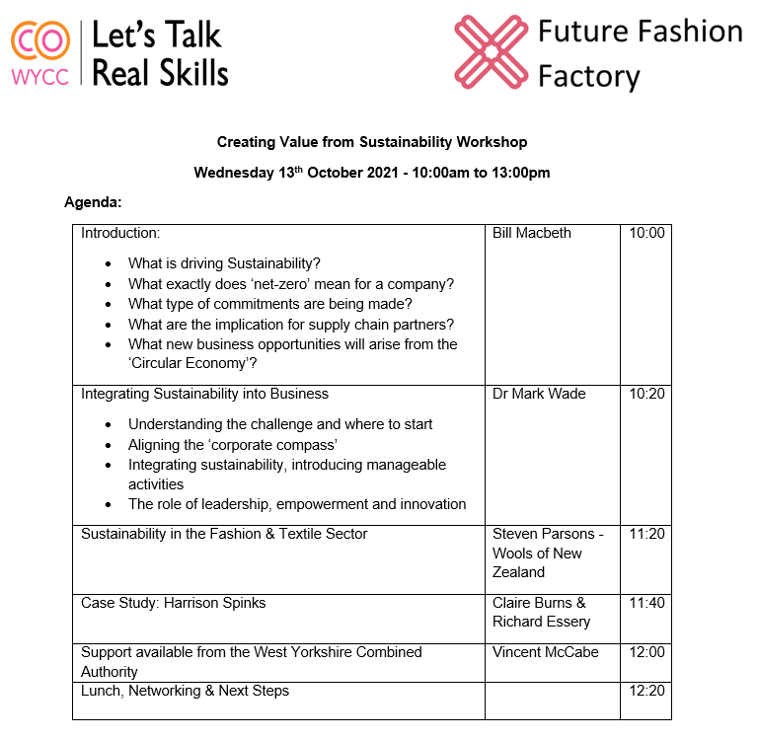
Company feedback from the Workshop was excellent and indicated a real demand for a new Programme of education and expert support to assist companies to develop and implement their own Sustainability Strategies. Following further consultation with companies the Centre proposed the development and delivery of an 8-month pilot programme for 20 delegates drawn from 10 participating companies. (Appendix 1) The programme was organised around a series of individual and group sessions facilitated by Dr. Wade and included participation in the IMD Winning Sustainability Strategies course.

IMD’s ‘Winning Sustainability Strategies’

Promoted as a 5-week online course requiring 5 to 6 hours study per week where delegates would build a strong business case for sustainability, improve their understanding of their purpose, strengths and weaknesses and develop opportunities for innovation, establishing appropriate targets and monitoring mechanisms, as well as aligning systems required to propel their business forward. The programme would be supported by a professional learning coach and delegates would leave with their own action plan, essential for stakeholder buy-in, plus all the tools and frameworks required to confidently lead their sustainability transformation. The program was structured in five units, covering the following topics:

Unit 1: Business in a changing world
- Finding out about the UND SDGs and key global sustainability trends.
- Learning about the vectoring model and its component parts.
- Completing the sustainability scoresheet for their own organisation.

Unit 2: Developing purpose-driven organisations
- Understanding the importance of focus on specific sustainability issues.
- Learning and applying the concept of materiality to their organisation.
- Reformulate company purpose.

Unit 3: Reporting on targets and progress
- Learning how to design a robust sustainability reporting framework.
- Understanding how to embed the SDGs into business strategy.
- Finding out how to successfully position sustainability within a modern business context.

Unit 4: Transformation toward a circular economy

- Understanding how to address opportunities and threats arising from the circular economy.
- Applying tools such as waste hierarchy and stakeholder partnerships.
- Examining circular strategies for solution development.

Unit 5: Implementing sustainability

- Creating a high-level action plan to implement sustainability strategy.
- Examining the potential of innovation platforms and collaborative networks.
- Anticipating resistance and securing engagement from teams.

Executive coaches made sure each delegate received an individualised learning experience, providing support and feedback to help to translate learning to a company’s context.
The Pilot Programme
The Programme included the following elements:
Phase 1 Week 1 – 4: Recruitment and Induction
Phase 2 Week 5 -6: Initial Company Assessment
Phase 3 Weeks 7 – 13: Learning and Benchmarking
Weeks 8 – 12: IMD ‘Winning Sustainability Strategies’ programme
Unit 1 Business in a changing world
Unit 2 Developing purpose-driven organisations
Unit 3 Reporting targets and progress
Unit 4 Transformation towards a circular economy
Unit 5 Implementing Sustainability
Week 13: Learning Review Event
Phase 4 Week 16 – 28 Planning and Doing
Strategy Development: Individual monthly company review visits and joint company review sessions.

Phase 5 Week 32 - 40 Review and Evaluation
Assessing the Programme’s impact and value, recommendations and next steps.
Funding Support
Financial support for the delivery and evaluation of the pilot programme was kindly provided by the Clothworkers’ Company the Arts and Humanities Research Council and the Cotton Textiles Research Trust.
Delivery

Stage1: Visits in May 2022 resulted in 10 local companies enlisting involving 24 participants, including representatives of the senior leadership of each. A late recruit joined in September, The Smock Works. Visits also served to assess the current status of the sustainability integration efforts of each company and future needs and challenges. A good working relationship was established as a basis for thought partnership in advancing thinking and action. Specific topics discussed in the visits included:
- A frank assessment of the status of a company’s sustainability related activities and readiness for further improvement. Who is involved in leading and/or championing the sustainability strategy integration efforts? What resources, time/empowerment, will they have?
- Where is the company at with defining values and purpose?
- What are the material issues facing the business as a whole and, if appropriate, by division?
- What initial thoughts are there on a vector for the company?
- What are the critical enablers and limiting factors to achieving your ambitions?

Stage 2: Of the 24 participants, 17 elected to enlist in the IMD online programme, including four CEOs/MDs. Participation in the online program was monitored and supported by the Centre through the provision of additional advice, perspectives, and tools delivered by Dr Wade. At the end of the program, the IMD issued certificates of successful completion.

Stage 3: A Learning Review event was held at the Centre on 13th July 2022 at which structured feedback on the IMD online program was received.
The consensus was that the program was very valuable and worthwhile, notwithstanding concerns over the IMD’s management of the early stages and some aspects of the learning process. Comprehensive feedback was given to the IMD with recommendations for improvement. (Appendix 2) The IMD acknowledged the learning points and expressed gratitude for the constructive feedback, the likes of which they had not had previously.

In addition, the event at the Centre provided a refresh of learning including tools, approaches, and on-going support for participating companies. Anecdotal feedback was highly positive citing the clarity brought to the subject and the approach offered for bringing further rigour and structure to each company’s embedding efforts.
Two themes emerged from the event along with a joint desire to pursue these collectively:

a) deeper learning on the circular economy
b) developing and testing a set of common KPIs as a framework with which to measure and report impacts, structure Action Plans, and be offered as a potential template for wider adoption by the textile and fashion industry.

Stage 4: In support of ‘Planning and Doing’ two visits to each company were offered, to be completed between July and November. The purpose was to provide bespoke advice and support in reassessing their sustainability integration priorities and bring structure to future efforts. Although each Pilot company is unique, common themes emerged. The need to:

• prioritise initiatives around material issues
• bring structure to integration efforts
• engage the wider workforce in understanding and involvement in delivery of sustainability ambitions.

Bespoke advice, tools and support were provided. It was observed that companies working with ISO 14001 were better placed to address the above given the rigour and reach of the process.

The ‘Ignite’ Event

In response to delegates’ request to learn more about approaches to the Circular Economy the Centre organised a joint event with the Knowledge Transfer Networks ‘Ignite Labs’ project. The joint event which took place on 26th October 2022 was entitled 'Circular Economy in the Textile and Fashion Industry - an opportunity to learn, share and network.' This was one of a series of 14 online and physical events held by the KTN between the18th October and 24th November. The audience included the Centre’s cohort companies, the KTN, the Ellen MacArthur Foundation, Revolution Zero, Daisy Chain project, Agency of Design, and the Future Fashion Factory. It was a very valuable focus for further development of sustainability thinking for the sector. The event was supplemented by a site tour and presentation by Harrison Spinks on their facilities and approach to the circular economy.
Common themes that emerged: included the need to prioritise initiatives around material issues; bring structure to integration efforts; engage the wider workforce in understanding and involvement in delivery of sustainability ambitions; and integrate actions with ISO 14001 where appropriate.
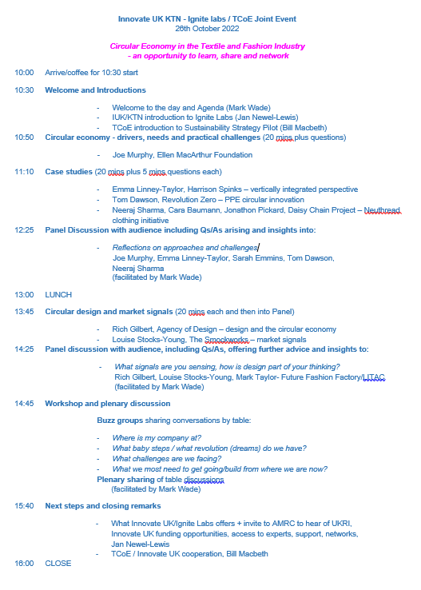
The KTN reported “The event at the TCoE bringing together of our Ignite Labs with your cohort of executives on your Sustainability Strategy course was a real highlight of the Ignite series”.

Evaluation and Proposals for Future Activity
Stage 5. A close-out/evaluation event took place on 25th January 2023 to critically assess the value of the Pilot to participating companies and their representatives. The program pilot was to be assessed on two parameters:
- value to companies
- value to the personal development of individuals.

In advance of the Review Workshop companies completed a questionnaire which provided detailed feedback on each aspect of the programme (Appendix 3). The feedback was very positive. Companies also identified a number of key actions which had been introduced as a direct result of participation. (Appendix 4). Key points from the evaluation:

- The programme had been successful and had achieved its objectives of bringing a structure to companies’ sustainability activities by sharing a common language, introducing analytical tools to prioritise risks and opportunities based on materiality, providing expert support to plan and implement change and developing strategies that involved all employees.

- Companies from the cohort were keen to continue to learn and collaborate. The programme had triggered a number of new sustainability-related business collaborations among the cohort.

- A subsequent programme should bring additional companies into the existing network, and not be a separate group.

- The IMD programme should be customised to reflect delegates’ time availability and the specific interests of the sector.

- The ‘Sustainability Roadmap’ was a useful tool to measure company progress towards integrating sustainability into their operation.

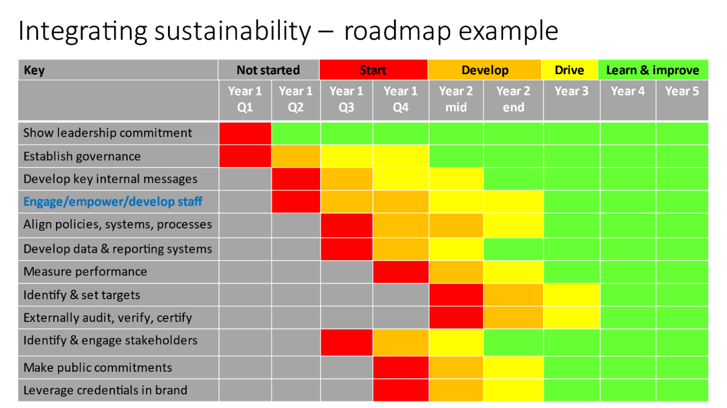
A number of proposals were made to build upon the success of the Programme and enable the growth the programme beyond the original group of companies.

- Develop a standard set of ‘Sustainability KPIs’.

Work with our group of businesses to define and test a set of common standard KPIs/metrics which, if they resonate across our cohort as a framework/structure for the development of their own Action Plans, might become a template for wider adoption.

Initially this activity would consider the relevance and value of the ISO Standard 14001 which offers certification of a company’s environmental management systems and consider the potential for adding or developing alternative specific industry relevant KPIs which might include:
- The existence of and senior level support for the company Sustainability Strategy
- Clear timetable for implementation of the activities defined in the Strategy
- Evidence of in-company capacity and responsibilities for implementation
- Targets for reduction in the use of power, water and chemicals over a set period
- Reductions in waste, effluent and heat production
- Internal ‘circularity activity’ or evidence of working with materials recycling and reuse organisations.

- Create a Sustainability Champions Network

Build on the capability, enthusiasm, and expertise of the cohort group by creating a ‘Sustainability Champions Network’ which would provide access to pre-competitive continued learning and personal development, increasing the awareness of and contact with sources of expertise and support, the sharing of best practice and build the capacity of the individuals, the participating companies, and the sector as a whole. Key activities:

- Identify range of company capacities with Cohort #1
- Identify key knowledge gaps and individual requirements
- Identify key support/sources of expertise and potential partner organisations
- Develop customised Personal Development Programme (PDP) model
- Identify options for network development and delivery methodology
- Design template for an online platform to share tools and learning
- Identify potential for peer and external mentoring.

- Create a Customised IMD ‘Winning Sustainability Strategies’ Programme for the Sector
The programme from the IMD proved to be popular with the cohort but the time required far exceeded the time stated. The next stage of development should:
- Review the IMD WSS programme
- Design a customised IMD programme to suit company capacities and interests across the sector
- Discuss with IMD and negotiate the development and delivery of the bespoke model.

- Create a Company Audit Support/Tool
Creating an industry-wide approach will require the development of a ‘toolkit’ to facilitate consistent analysis. Activities will include:
- Review availability, content, and methodology of existing, funded ‘energy audits’ and regional variations e.g., West Yorkshire LEP Resource Efficiency Fund
- Design enhanced service to identify baselines for individual company performance in activities relating to KPIs (energy use, water use, waste, effluent, CE activity etc.)
- Design a recording/ reporting tool that sets targets, timings and prioritises actions, recognising company capacities
- Investigate potential for development of software tool to assist companies with auditing, managing and reporting. Some examples exist, such as Toitu Envircare’s e-manage tool that comes with an audit package and certification of energy/carbon to ISO14064-1.

- Extend the Programme to Cohort #2
The programme has proved popular with companies and has clear potential to be rolled out to a wider audience. Key activities:
- Consider preferred entry requirements, size, capacity, ambition, stage of development
- Determine preferred range of functions (designers, manufacturers, apparel, textiles)
- Consider scope for including individuals from supply chain partnerships to work together
- Determine geography for Cohort #2
- Identify additional sources of expertise, support and partnership (UK and EU)
- Identify potential for branding/sponsorship
- Prepare plans for marketing and promotion.
This report aims to provide information that will inform a discussion with the industry and supporting agencies to steer the future approach.

Textile Centre of Excellence
March 2023

Appendix 1

Sustainability Strategy Pilot Participants list

S/N | First Name | Last Name | Job Title | Company | Program
1 | Andy | Ogden | Director and General Manager | English Fine Cottons | TCoE Pilot/IMD WSS
2 | Muhammad | Hanif | Group Divisional Operations Manager | English Fine Cottons | TCoE Pilot/IMD WSS
3 | Samantha | Russell | Retail Brand Development Manager | Antich and Sons | TCoE Pilot/IMD WSS
4 | David | Antich | Managing Director | Antich and Sons | TCoE Pilot
5 | Daniela | Petre | New Product Development Manager | Antich and Sons | TCoE Pilot/IMD WSS
6 | Ian | Burn | Director of Marketing and Sustainability | Camira Fabrics | TCoE Pilot/IMD WSS
7 | Paraskevi | Fotoglou | Sustainability Manager | Camira Fabrics | TCoE Pilot/IMD WSS
8 | Mantas | Rucinskas | Plant Manager | Camira Fabrics | TCoE Pilot/IMD WSS
9 | Matthew | Butler | Non-wovens fillings manager/recycling | Harrison Spinks | TCoE Pilot/IMD WSS
10 | Claire | Burns | Director of People and Talent | Harrison Spinks | TCoE Pilot/IMD WSS
11 | Emma | Linney-Taylor | Sustainability coordinator | Harrison Spinks | TCoE Pilot/IMD WSS
12 | Ethan | McGuigan | Process engineer | Harrison Spinks | TCoE Pilot
13 | Sarah | Emmins | Materials scientist | Harrison Spinks | TCoE Pilot/IMD WSS
14 | Richard | Essery | Director of Sustainability and Innovation | Harrison Spinks | TCoE Pilot
15 | Joanne | Sykes | Director | Brierley Brothers | TCoE Pilot - Not active
16 | Sarah | Price | Technical Assistant | Wooltex | TCoE Pilot/IMD WSS
17 | Richard | Brook | Managing Director | Wooltex | Supportive of TCoE Pilot
18 | Laura | Wood | Technical Manager | Wooltex | TCoE Pilot
19 | Paul | Johnson | Managing Director | WT Johnson | Supportive of TCoE Pilot
20 | Neil | Calvert | SH&E Manager | WT Johnson | TCoE Pilot/IMD WSS
21 | Sonya | Bachra-Byrne | Director | Avie | TCoE Pilot/IMD WSS
22 | Amanda | McLaren | Managing Director | AW Hainsworth | TCoE Pilot/IMD WSS
23 | Zena | Al Mausawe | Director of Operational Excellence | AW Hainsworth | TCoE Pilot/IMD WSS
24 | Louise | Stocks-Young | Owner | The Smock Works | TCoE Pilot - new member
25 | Steven | Parsons | General Manager Sales & Marketing | Wools of New Zealand UK Limited | TCoE Pilot/IMD WSS
25 | Bill | Macbeth | Managing Director | TCoE
26 | Mark | Wade | TCoE Advisor

Appendix 2
IMD online Winning Sustainability Strategies Programme
The Textile Centre of Excellence Cohort Feedback
Process and experience
Set-up
- Information prior to the program on the process and effort required to get set-up was very poor. The importance of having a working knowledge of CANVAS was not covered.
- The time required to fully participate in the course work, buddying and groups assignments (4-6 hours a week) was seriously misleading.
- The amount of background reading and research required at least 10 hours per week if not more. Group and Buddy sessions themselves could take more than two or three hours with background preparation work and editing. As a result, many committed much more time than indicated wishing to fully participate and engage with the program, while others simply could not devote this amount of time and had to drop out.
- There was a missed opportunity to cover all of this honestly and comprehensively in the ‘Kick-off’ event, and in conversations ahead of the decision to invest in the program.
- The timing of the program coinciding with public holidays further compounded issues. It added to the stress in wishing to complete tasks to unrealistic time frames.
Recommendation: provide a realistic indication of the effort, skills and set-up required. Provide more time ahead of the course work to get-set-up and become familiar with the systems. Anticipate and allow for public holidays in scheduling workload.
Administration
- The administration and organisation during the program were poor.
- In some cases, it was 10 days into the program, before group members were informed that others linked to the group would not be participating. Changes to groups membership was way behind the reality, despite IMD being informed of known changes to availability of individuals.
Recommendation: provide timely information to groups on participation.
Mentoring
- The time with mentors was generally low. Feedback to submitted work was often scant and without depth or substance. Generally, this was limited to praise and encouragement when what was sought was serious critique, constructive comments and deeper insights and learning points. On the positive side, the general engagement with participants was far superior to that of more traditional ‘Masters’ program student engagement.
Recommendation: provide serious mentoring.

General observations
- Participants felt there was a process rush over learning with insufficient time allowed to digest information and reflect on its relevance and applicability.
- There was a fear of failure from the time and grading approach, which as felt to be not constructive to genuine learning.
- The Group and buddy experiences had good dynamics, once the set-up was overcome.
- The opportunity for learnings from the cross-industry and international pairings was a real positive and much appreciated.
Recommendation: allow more time for absorbing and reflecting on new information (use mentoring as a part of this). Provide a steer on group management at the outset, e.g., in appointing or providing advice on appointing a leader/roles in the groups.
Content
- Participants found the program inspiring and insightful and the new tools helpful to building a sustainability strategy for integration into the business.
- The content was generally felt to be of good quality. The Materiality tool was seen as particularly helpful.
- The WWS book was very dry. Some of the examples were too niche, not scalable and way out of date.
- The way the book was presented for screen reading was very poor. No attempt had been made to make it screen friendly in layout, type font and general readability. This was a disappointment given how central the book was to the program.
- There was an over reliance on Finch & Beak approach and thus too many examples from Dutch business. A more balanced, international perspective was missing.
Recommendation: invest in making the book screen friendly. Consider a Kindle version. Having a ‘hand’ version as an alternative to a hard copy book would enable more opportunities for study. Widen the base of cases to reflect a more international perspective.

Impact
- The program triggered positive activities in the participant’s companies.
- The Materiality tool was particularly instrumental. It provided a structured approach to sharing views on priorities with colleagues up and down the line. It was seen as a tool that others could apply in their context, even Board members.
- The tools generally gave a sense of empowerment to sustainability champions to challenge management in a constructive and logical manner. They enabled a shared perspective on what is important and how to priorities initiatives.
- The program provided a good challenge to companies and made them think. It provided a wake up to the fact that ‘we think we are good, but we don’t really have a defined sustainability strategy.’

Conclusion
Overall, a positive and worthwhile experience delivering genuinely useful tools of applicability to structure and priorities material factors and share views. The learnings and tools empowered sustainability champions to challenge management in a constructive and structured manner.
Much to improve in set-up, management, and mentoring. A screen friendly version of the book would enhance its usability.


Appendix 3

TCoE Sustainability Strategy Development Programme Pilot
Participant Feedback Analysis
Participants in the Pilot were invited to submit their critical insights into the programme by completing an online questionnaire. All submissions were anonymous.
The survey covers the main elements of the Pilot and asked for feedback on its value to the personal development and learning of participants and to their companies.
The results presented here form the basis for discussions at the Close Out Event, 24th January 2023, to evaluate the Pilot and inform the design of a possible Phase 2.
Section 1
IMD ‘Winning Sustainability Strategy’ online Program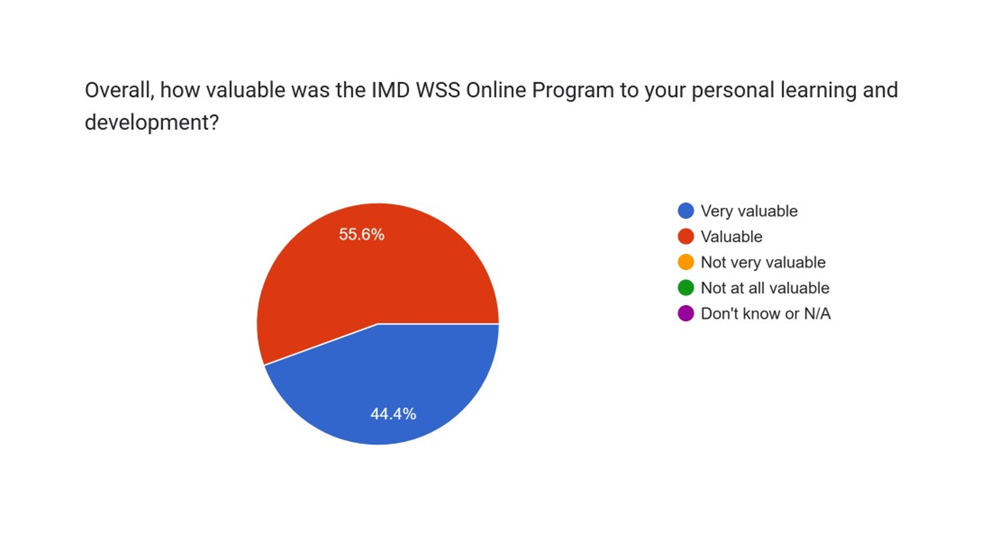

What elements of the IMD WSS Online Program, if any, were particularly helpful/impactful to your personal learning and development?
- Materiality matrix.
- Team exercises- group case study work to deadline. Broad overview of sustainability concepts.
- Understanding the development of CSR into ESG and how each element of the "E" "S" and "G" inter-relate to sustainable business.
- Pair and group work, the chance to discuss ideas and share learnings.
- The general framework provided by the course was useful (i.e. Vectoring -> materiality -> circular economy).
- Learning about frameworks and the application.
- My intention was to gain an understanding of "What sustainability meant" especially to our customers.
- Materiality - Sustainable Development Goals - Circular Economy concept.

What elements of the IMD WSS Online Program, if any, were particularly helpful/impactful to your personal learning and development?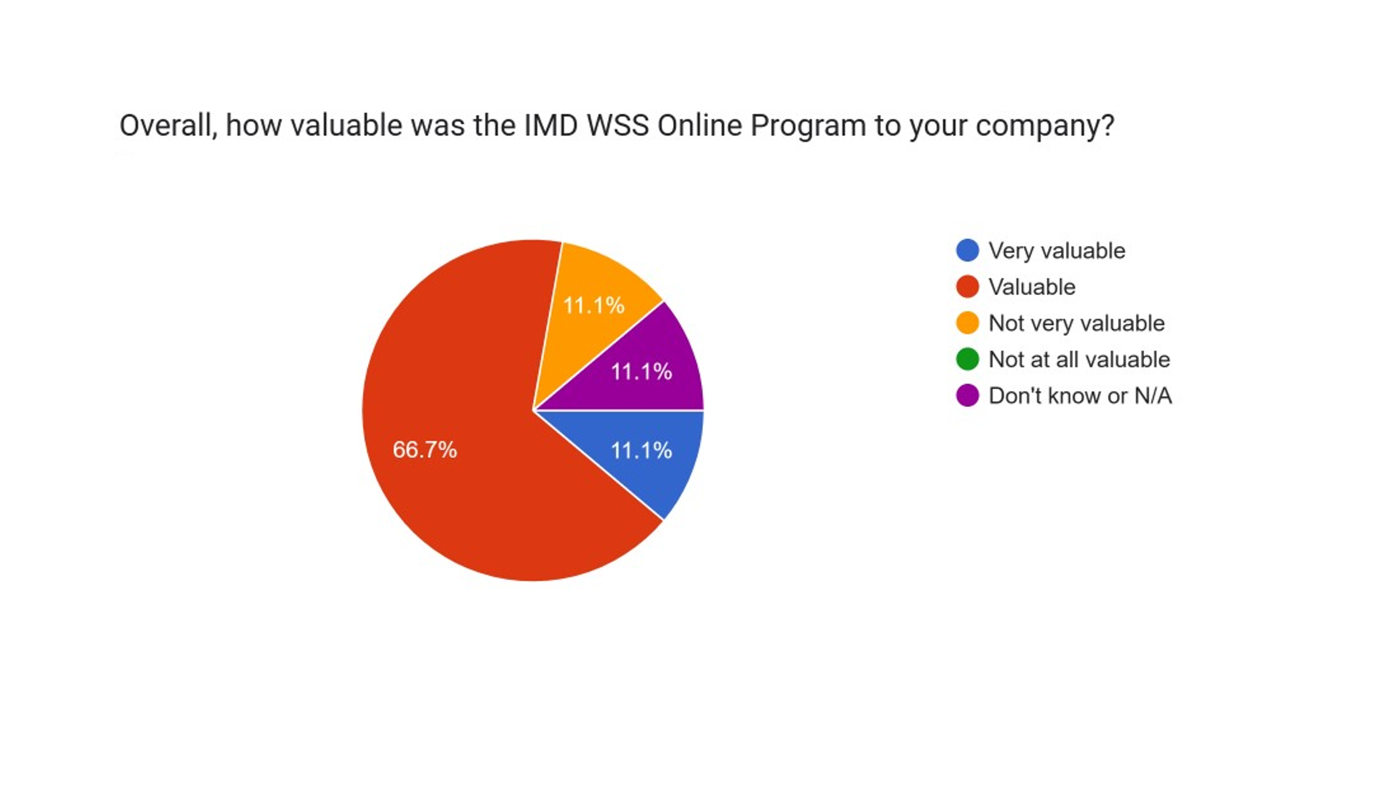What significant actions, if any, did it trigger in your company?
- Identifying priority issues.
- Work to undertake a Materiality Assessment.
- Building finance (Profit) the sustainable strategy, linking every decision and objective into tangible financial improvement, or showing levels of risk reduction.
- Unsure if any specific actions arose from the online course itself but having been able to build connections with industry colleagues through the program, we have pursued knowledge sharing and potential partnerships with a number of participating businesses.
- We have started at the beginning and are reviewing our purpose and values and are planning on following through the steps to embed and create a sustainability culture.
- The addition of a specific, but integrated, sustainability management system into the business. Additionally, it kicked off conversations around is sustainability a function of "The Environment", "Business Continuity", both or should it sit as a separate management structure.
- Focus on developing future projects that take into account sustainability and/or place it at the core of the respective project - developing a project. Implement recycling initiatives across the company - design a communication strategy to educate and inform all teams about the importance of recycling and how to implement it correctly. Develop an action plan for next year's sustainability report - targets for end of 2023.
- Used the Vectoring Model to establish direction of travel and selected the Materiality Projects carefully, with a handful in mind, to ensure success.
Given the opportunity to customise the IMD WSS Online Program to the textile and fashion sector, what would you like to see it contain that the generic version did not?
- Examples of how sustainability has influenced other textile manufacturing and retail companies. What metrics and reporting standards they use.
- Introduction to Net Zero.
- More focus on how "sustainability" and environmental impacts are being handled within the global industries, (perhaps case studies on Patagonia, H&M, IKEA, and raw material suppliers (wool, cotton) and specific synthetic fibre manufacturers and the movement to bio-based solutions (Hyosung latest bio-based elastane!).
- I liked that the case studies came from other industries as I think there is much to learn from that, but it would have been nice to have an opportunity to talk about how each learning point could relate directly to the industry rather than leaving them hanging there in a general sense. Also spreading the program out or having a 'reading week' period of a break from studies but a chance to start looking at implementing ideas into the business.
- The case studies were useful but were written by the course tutors (outside the company). It would have been great if some of the cases were presented by people who had gone through the sustainability journey first hand within a company to understand more what challenges they had. Also, more relevant benchmark data for things like the ESG canvas would have been useful.
- More case studies within this sector.
- More emphasis upon what sustainability means to different business i.e., the sustainability of the work force (Attracting young people) is important to one company whereas the continuity of supply of wool is more important to others and specific case studies.
- Information regarding the potential methods of recycling textiles (based on type of fabric), and impact (CO2 footprint & others) of the process. Information regarding durable and sustainable materials as potential candidates for new generation of sustainable fashion garments
- Case Studies of Businesses excelling from a Sustainability perspective, in our Sector.
If you were given the opportunity to customise the IMD WSS Online Program to the textile and fashion sector, what would you like to see less of/drop from the Program?
- Drop examples/case studies on niche companies that have no relevance to the textile industry in the UK.
- Reduce the number of individual elements per module - need to be very vigilant to cover all aspects (i.e., not miss specific tasks).
- Needs to be slightly less intensive, having Buddies, and Group assessments, generally covered the same ground and objective of collaborative discussion and understanding different perspectives, is there a need for both? Removing buddy tasks for example will remove some of the intensity in some weeks.
- Slightly less intensity! Same amount of content over a longer period.
- I wouldn't drop anything.
- Case studies from unrelated businesses.
- All information might be relevant to different participants.
- More time to complete the Programme - it was very intense for Business Leaders to complete in the timeframes set. Also, putting some structure or recommendations around how groups should work together best.
Section 2
Company Visits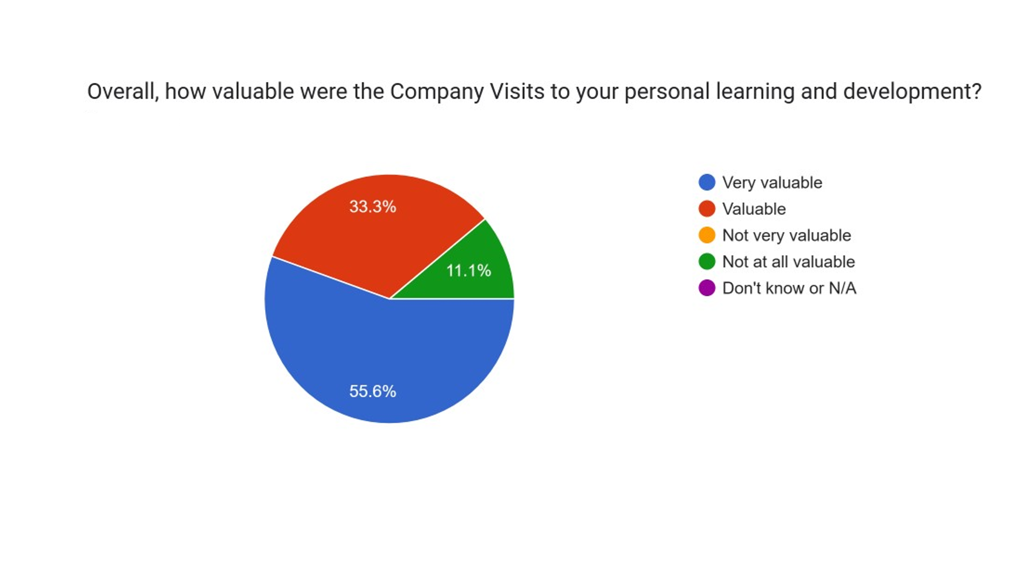
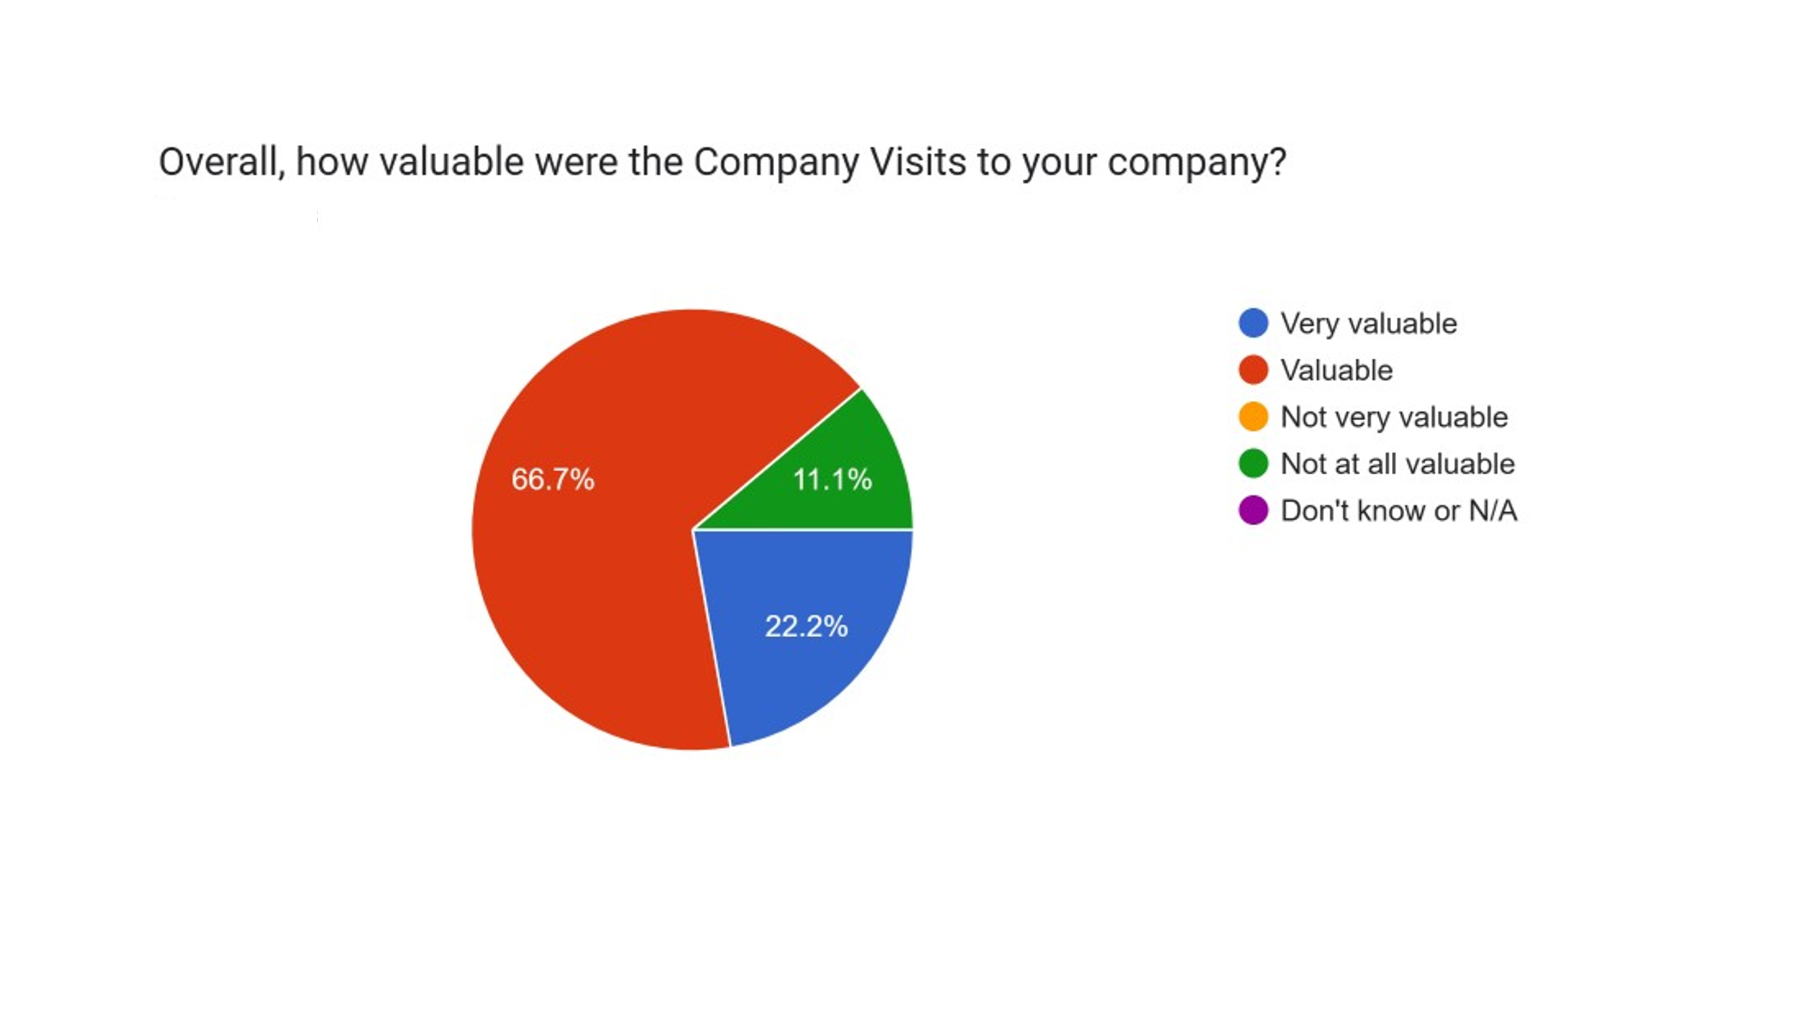What aspects of the Company Visits, if any, were particularly helpful/impactful to your personal learning and development?
- Gave an opportunity to put things into perspective and get deeper insights into what was important.
- Ability to go a little deeper into specific topics, e.g., Materiality.
- Didn’t undertake any.
- Knowledge sharing on certifications and systems of work, offerings of potential partnership.
- The visits gave great insight into how other businesses were approaching the topic of circularity.
- Having a structure in place and an outside perspective.
- To understand what other businesses use as "raw materials" & what they consider as "waste" and the opportunity to see if there are any tie ups to reduce any wastes that may go to landfill or combustion.
- The input received from Mark Wade was helpful since it provided some ideas on how certain aspects of the overall business might be improved (e.g., look into proper insulation and energy consumption around the factory premises). Input regarding companies that deal with carbon and energy audits needed to investigate our CO2 footprint. Input regarding way of communication efficiently with our teams, relaying messages and taking action in a more focused manner.
- Opportunity to focus on our Business alone and draw from the experience to hand.
What significant actions, if any, did they trigger in your company?
- Re-thought Purpose and values. Helped us prioritise actions and develop an action plan.
- Work on a Materiality Assessment.
- None.
- Learnings for how to implement systems for ourselves.
- They gave us an opportunity to make use of one of our waste streams.
- Supplying of waste fly and flock samples to other businesses who may be able to make use of them.
- Currently, no actions were taken.
- To consider the strategy of 'REDUCE' much wider than we had previously.
How could the Company Visits be improved to meet your needs in your company? What would you like to see more of and/or added?
- Could supplement with additional follow-up Zoom/Team Meetings calls.
- No suggestions - beneficial as undertaken.
- N/A.
- Nothing to add.
- Nothing.
- Application of the IMD course to be aligned with the needs of the company.
- More detail around what different businesses use as raw materials and produce as waste.
- Advice and more in-depth input on the sustainability plans designed by each company.
- Recommendations/Action Plans / Initiatives to help us define content better.
How could the Company Visits be improved to meet your needs in your company? What would you like to see less of/drop?
- Nothing obvious.
- No suggestions - beneficial as undertaken.
- N/A.
- Nothing to add.
- Nothing.
- All of the information provided is very welcome.
- Nothing in particular.
Section 3
Pilot Events
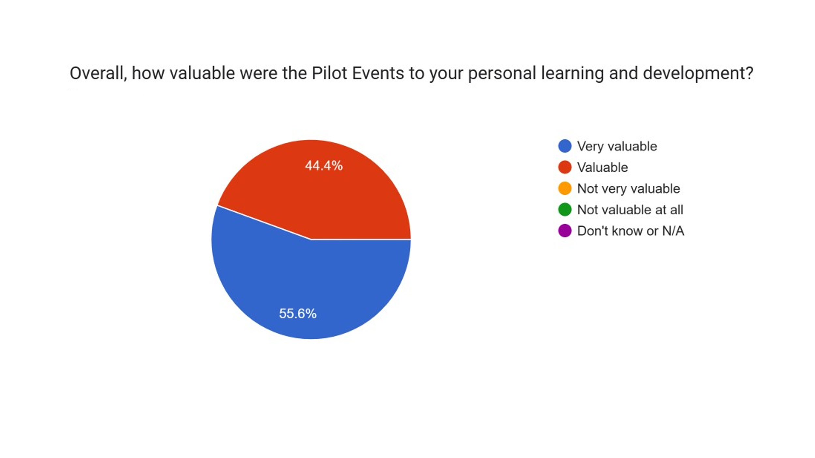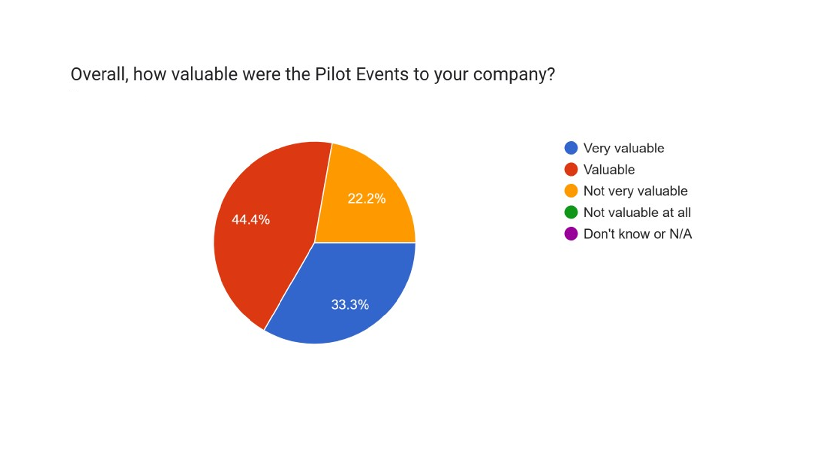

What aspects of the Pilot Events, if any, were particularly helpful/impactful to your personal learning and development?
- Hearing things again helped reinforce learning. Circular economy event was inspiring and relevant to advance our thinking.
- No specifics - just a good general intro.
- Understanding a broader picture from companies who are in the sector but not in our sphere of work.
- Networking and building connections with people doing similar work in different companies and sharing our experiences.
- Additional learning, and food for thought.
- The identification of the sustainability frameworks and the presentations by industry leaders
- Introduction to the topic.
- The Pilot Events were helpful to meet with other participating companies and understand if there is any common ground that could be used as the start-up for a collaboration/project.
- A wider appreciation of how a Business Model can change, as a result of its sustainability strategy.
What significant actions, if any, did they trigger in your company?
- Led us to think what to do about some of our waste and where we send it.
- No specific actions.
- Looking a circularity in a different way
- None noted.
- Nothing.
- Refining the actions that needed to be taken to have a social, planet purpose clearly identified.
- Stimulus to create the sustainability management system.
- There was no action taken as a follow-up of these events.
- To be more inclusive, to form a committee, to appoint a champion and to drive an action plan.
How could the Pilot Events be improved to meet your needs/those of your company?
More time for group discussions to help thinking about the relevance/how to apply learning to our own company.
- Include Net Zero.
- Better long-range diary planning.
- No improvements noted.
- More relevant elements for manufacturing, much was focussed on product/process design and Not efficiency of manufacture (or manufacturability).
- Please see my previous answers.
- Quite difficult to say as these events involve competing companies and the information shared during the event seems to be quite limited.
- More Industry relevant - modern and recent case studies.
Section 4
Networking and Peer Group Learning
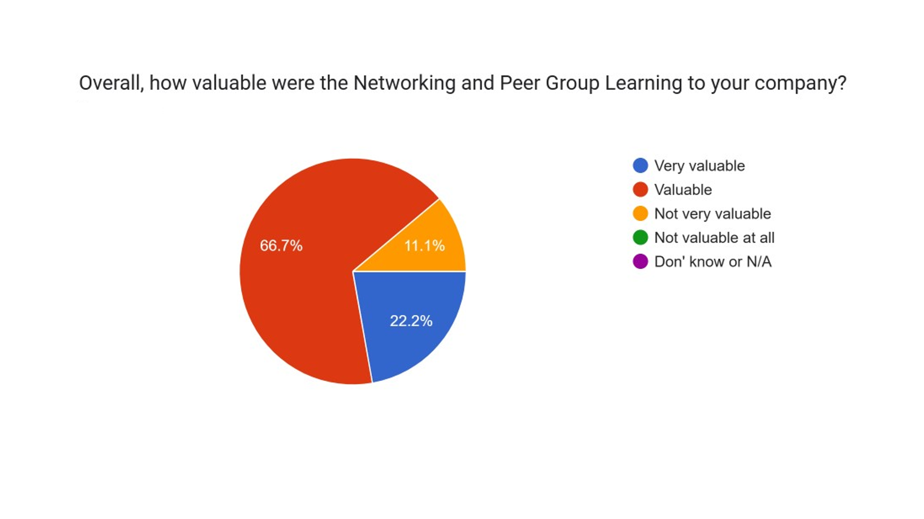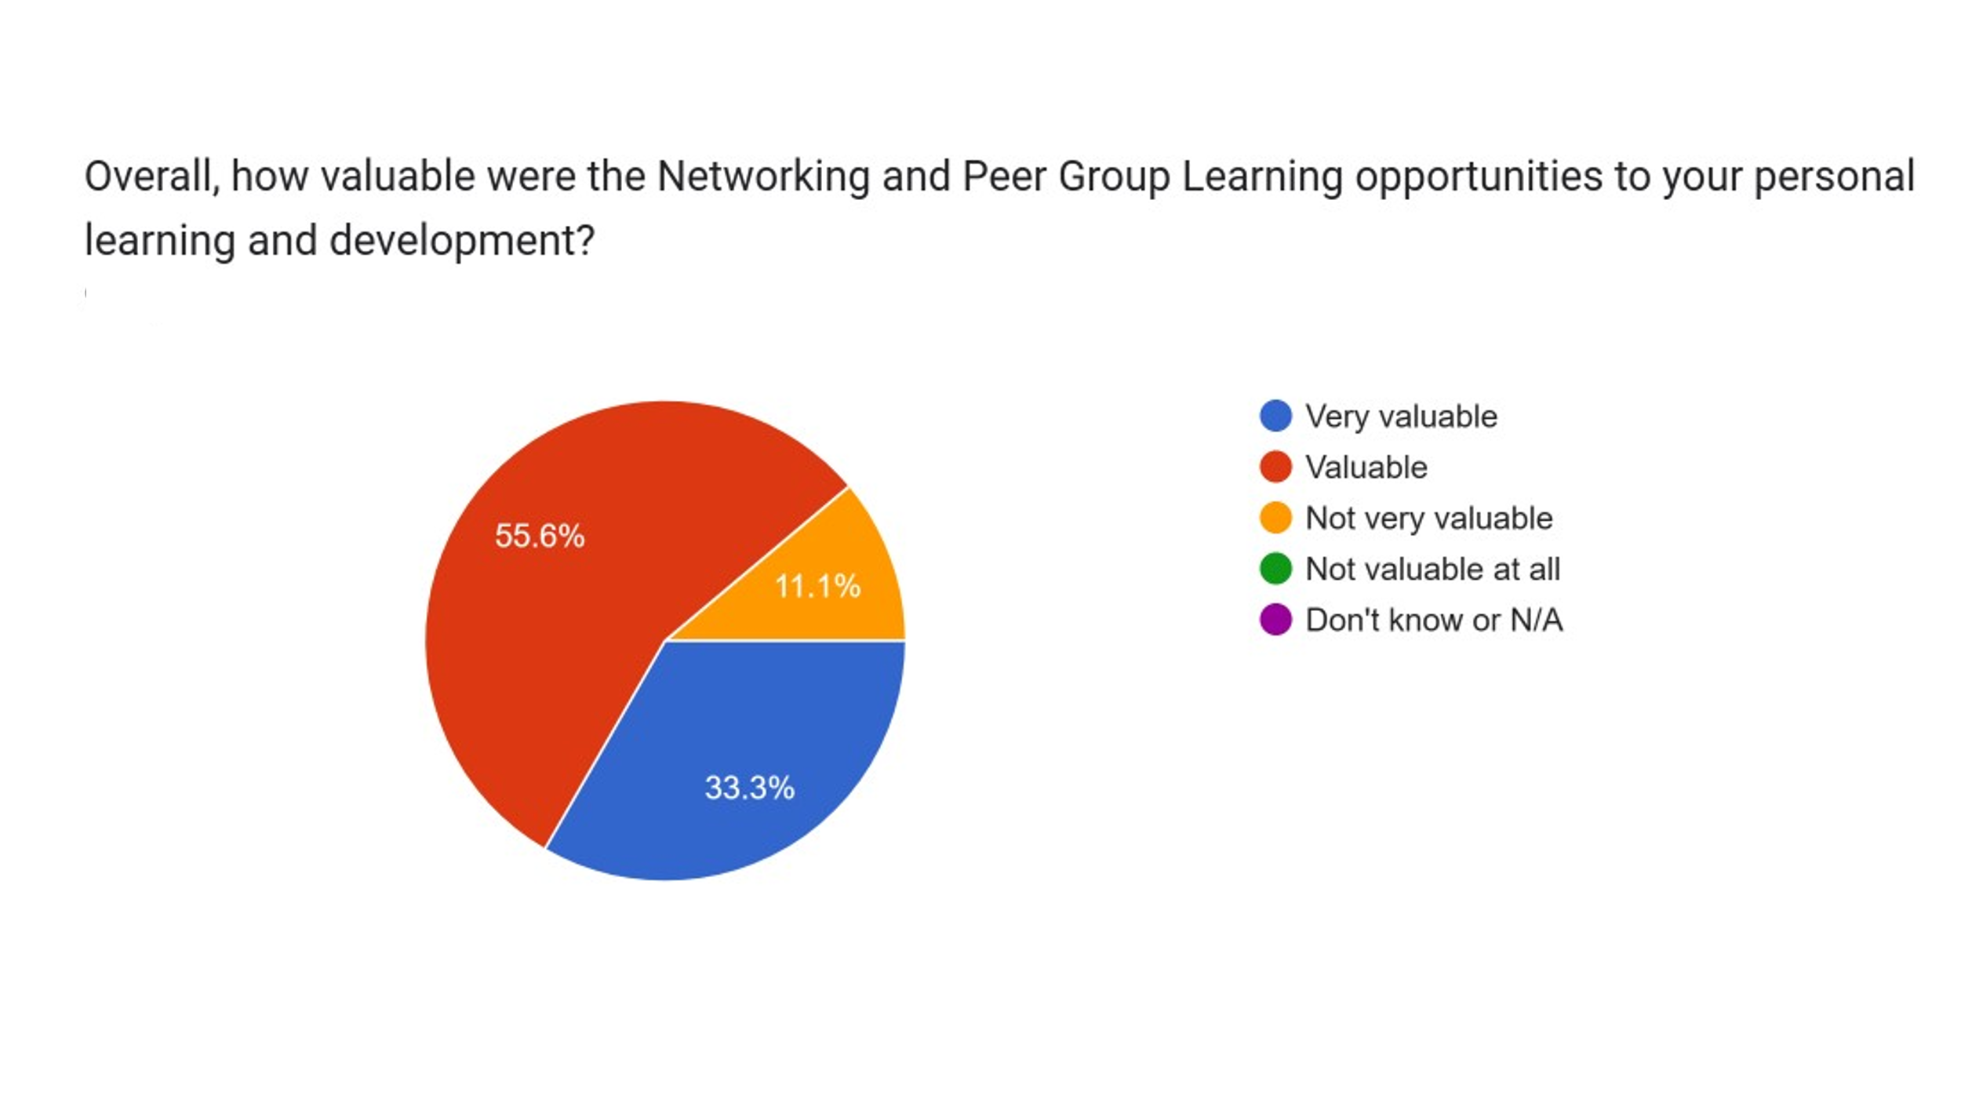

What aspects of the Networking and Peer Group Learning opportunities, if any, were particularly helpful/impactful to your personal learning and development?
- Learning from others that we more advanced in applying standards such as ISO14001.
- Understanding the complexities of other industries (Banking and finance).
- Sharing knowledge, building networks across industry.
- Met some very interesting people in the industry who shared with me their understanding and experience which will help me greatly with my questions.
- Just learning from others and their processes.
- To be able to discuss what sustainability means to other businesses, how to manage it and waste to raw material tie-ups.
- It was useful to understand what other companies do and identify any collaboration opportunity. The feedback from each company regarding their sustainability journey was not entirely open due to competing reasons so that limits a bit the collaborative aspect that could be improved.
- Hearing different viewpoints, experiences and also how different Industries are working towards their sustainability objectives.
What significant actions, if any, did they trigger in your company?
- Advanced our plans for adopting ISO 14001.
- None.
- Increased understanding of industry specific challenges and opportunities.
- Helped with consideration of how we roll out some elements of education.
- To implement future plans based on when we scale the company forward.
- Please see my previous answers.
- None.
- More inclusivity and different ideas to the table.
How could the Networking and Peer Group Learning opportunities be improved to meet your needs and/or those of your company?
- Set-up Peer group formally and provide shared platform for info exchange and arranging meetings.
- Having more within the group (we had a group of 2)
- None.
- No issue.
- Going into events with specific knowledge of what that individual's business uses as a raw material, what it produces as waste, and its specific goals in terms of sustainability.
- Nothing in particular - just interesting to hear approaches to shifting culture.

Section 5
Cross-cohort Business Opportunities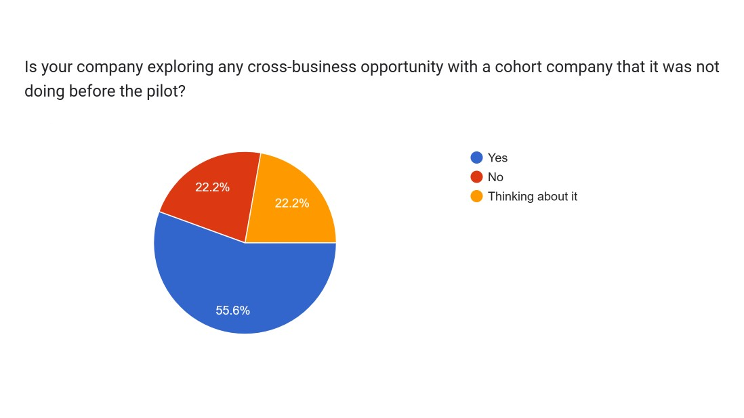
Section 6
Champions Network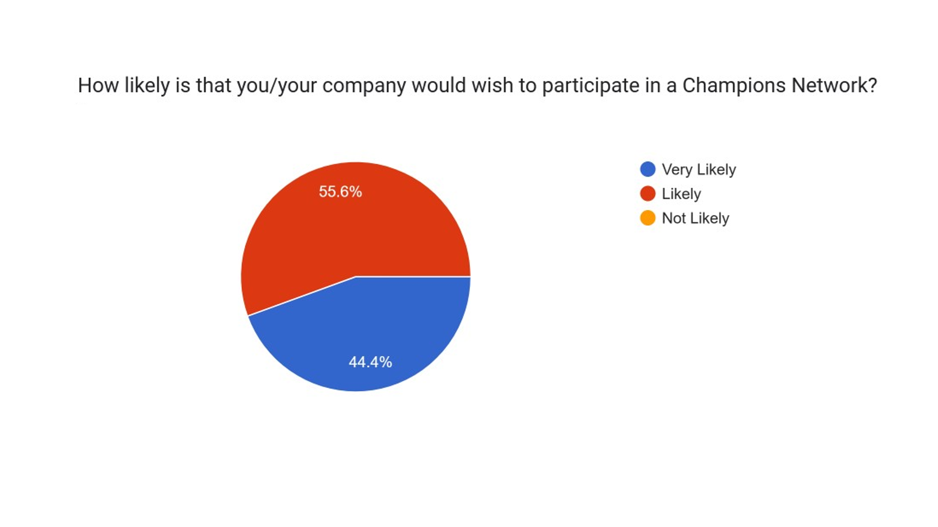

Section 7
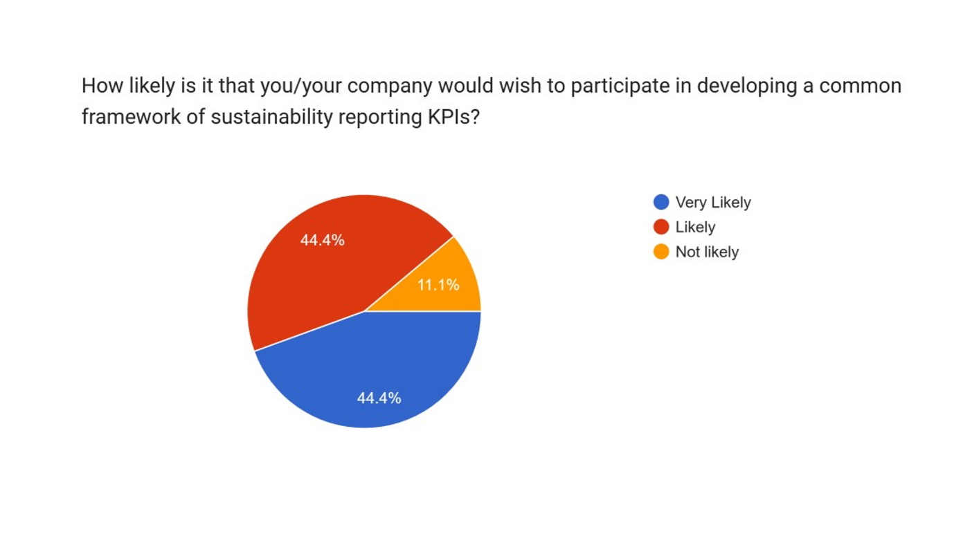
Developing a Common Framework of Sustainability Reporting KPIs?
Section 8
Developing a Recruitment for the Local Textile and Fashion Industry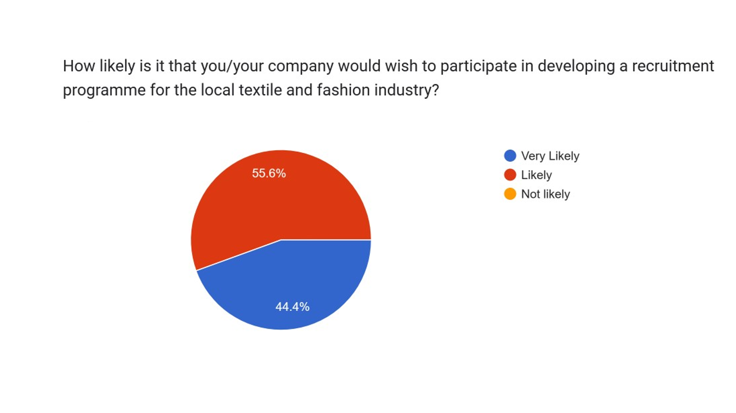
Section 9
Recommending the TCoE Sustainability Strategy Development Programme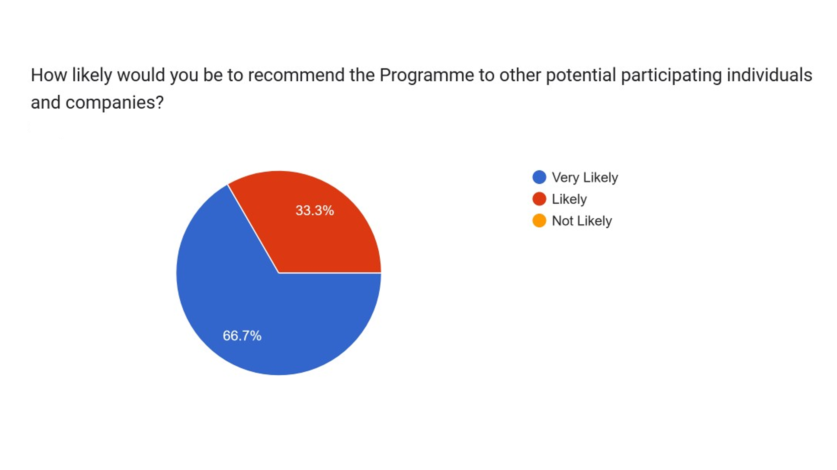
16.01.2023
M Wade

Appendix 4
Significant Company Actions
& Testimonials

- Re-thought our ‘Purpose & Values’ as a company and placed sustainability at the heart. Supporting this by taking steps to embed and create a sustainability culture company wide.
- Building a sustainable finance strategy, linking every decision & objective into tangible financial improvement and/or risk reduction.
- Identifying priority issues and undertaking a sustainability Materiality Assessment.
- Developing future projects taking into account sustainability considerations and placing them at the core of decision making.
- Implementing recycling initiatives company wide.
- Developing a communication strategy to educate and inform and engage all teams at all levels across the company.
- Developing a Sustainability Action plan for incorporation into a Sustainability Report, including key targets, for the end of 2023.
- Prioritising sustainability actions and developing a clear implementation action plan.
- Undertaking a sustainability Materiality Assessment.
- Learning for how to implement systems for ourselves.
- Triggered us to make use of one of our waste streams [as a value stream].
- Motivated us to apply the strategy of 'REDUCE' much wider than we had previously.
- Supplying of waste fly and flock samples to other businesses who may be able to make use of them. Led us to think what to do about some of our waste and where we send it reducing environmental impact and cost.
- Looking at circularity in a different way.
- Refining our actions needed to have a social, planet ‘purpose’ clearly identified.
- Stimulated us to create for ourselves the sustainability management system advocated.
- Got serious about being more inclusive, to form a [sustainability] committee, to appoint a sustainability champion and to drive an action plan.
- Advanced our plans for adopting ISO 14001.
- Increased understanding of industry specific challenges and opportunities
- Helped with consideration of how we roll out some elements of [sustainability] education.
- To implement future plans based on sustainability when we scale the company forward.
- Driving inclusivity and encouraging different ideas to the table.

TCoE’s Sustainability Strategy Programme was fantastic for UK textile manufacturing. It brought together Yorkshire’s (and Lancashire’s) leading textile companies, all working towards improving their knowledge and practice in sustainable development. Starting with an intensive online interactive study course “Winning Sustainability Strategies”, led by Lausanne Management School IMD, the programme provided a great foundation for developing in business sustainability strategies. The programme benefited from the practical guidance and expertise of sustainability consultant Mark Wade, who advised on the practical implementation of sustainability programmes through in-company visits, plus collaborative group networking events at TCoE helped cement learnings and discuss common challenges”.

Ian Burn. Director of Marketing and Sustainability. Camira

As a Business Leader, it allowed me to take time out through the programme, to wholly focus on our approach to a Sustainability Strategy, adopting the methods and framework to allow us to move on successfully and confidently in our approach.
Amanda McLaren. Managing Director. AW Hainsworth & Sons

When we launched English Fine Cottons, we placed sustainability at the heart of every decision we made and believed we understood the questions we needed to answer . Enrolling on the IMD course , we soon learned that these decisions needed to focus on making a profitable business , while also doing good and looking after the future. Sustainability isn’t only about the materials and processes you use. The course provides in-depth understanding of the subject matter, with simple to follow tools to help you achieve a successful sustainable plan . We would recommend any UK textile company enrols on the course to help them and the whole community to thrive and prosper into the future.
Andy Ogden. Director & General Manager. English Fine Cottons

